**Phthalates and Incident Diabetes in Midlife Women: The Study of Women’s Health Across the Nation (SWAN)**

Short title:Phthalates and diabetes in women

Mia Q. Peng,Carrie A. Karvonen-Gutierrez, William H. Herman, Bhramar Mukherjee, Sung Kyun Park

**Supplemental Materials**

**Inverse-probability-of-treatment weights**

For each phthalate metabolite, we weighted each observation by the following inverse-probability-of-treatment weights (IPTW):

IPTWij = ,

where *i* indicates an individual, and *k* indicates a time point. *k* takes the value of 1 or 2, with *k* = 1 corresponding to Visit 3 in 1999/2000, and *k* = 2 corresponding to Visit 6 in 2002/2003. *Zi* is a vector of time-constant covariates measured in 1999/2000, which included age in 1999/2000, site and race/ethnicity, and education. *Lik* is vector of time-varying confounders for individual *i* at time point *k*, which included dietary energy intake, smoking status, physical activity, and menopausal status in IPTW-weighted marginal structural model (MSM) 1 and additionally included (lagged) BMI in IPTW-weighted MSM 2. We constructed two IPTWs to evaluate the impact of BMI on the association between phthalates and incident diabetes. Unlike our main analyses, site and race/ethnicity was combined into a 10-level variable in the construction of IPTWs. These ten levels corresponded to all observed race/ethnicity and site combinations in SWAN-MPS. We used the 10-level variable because by design, each study site recruited White women and women of one other race/ethnicity. In other words, not all possible race/ethnicity and site combinations were represented in SWAN-MPS. Using race/ethnicity and site as separate predictors of phthalate metabolites in the construction of IPTWs would have violated the positivity assumption of the inverse probability weighting method (1).

The denominator of the IPTW was the conditional probability of having a phthalate metabolite concentration infinitely close to the observed phthalate metabolite concentration for woman *i* at time point *k*, given *Lik* and *Zi.* This likelihood was evaluated at the observed value of the phthalate metabolite based on a normal density function. The mean and standard deviation of this normal density function was obtained via a generalized estimating equation (GEE). The GEE had log2 (phthalate metabolite) as the outcome, *Lik* and *Zi* as predictors, and an exchangeable correlation matrix. The numerator of the IPTW was obtained in a similar manner, except that the GEE model used to predict log2 (phthalate metabolite) included only the time-constant covariates, *Zi*,as predictors. After constructing the IPTWs, for each phthalate metabolite, we fit the following IPTW-weighted marginal structural Cox proportional hazards model with a robust variance estimator:

λ(t) = λ0(t) exp (β1 log2 (phthalate metabolite) + βz )

Weighting each observation by the IPTW created a pseudo-population in which phthalate metabolite concentrations were not associated with time-varying confounders included in *Lik*. Thus, the MSMs allowed us to eliminate confounding by BMI and other time-varying confounders without having to adjust for them in Cox models. Note that because the numerator of the IPTW depended on *Zi*, phthalate metabolite concentrations in the weighted sample were still associated with *Zi*. Therefore, *Zi* was adjusted in the IPTW-weighted marginal structural models to eliminate confounding by time-constant covariates (1). We created the IPTWs with the R package “ipw” (version 1.0-11). Details about this package are available in Wal and Geskus 2011 (2).

**Inverse-probability-of-selection weights**

We weighted each observation by the following inverse-probability-of-selection weights (IPSW):

IPSWi = IPSW1i × IPSW2i,

where i indicates an individual, and IPSW1i and IPSW2i each represents the two selection processes

into SWAN-MPS: 1) continuing in the SWAN Study through Visit 3 and 2) being selected into SWAN-MPS, given being active in SWAN at Visit 3 in 1999/2000.

**Construction of** **IPSW1**

IPSW1 was calculated as follows:

IPSW1i = ,

where *i* indicates an individual, and *k* indicates a visit. *k* takes the values of 1, 2, 3 and represents SWAN Visits 1 through 3. Cik is a binary variable: Cik = 1 represents dropping out of the SWAN Study by Visit *k*, and Cik = 0 represents otherwise. *Zi* is a vector of time-constant predictors of drop-out measured in 1996/1997, which included age in 1996/1997, race/ethnicity and site, and education. *Lik* is vector of time-varying predictors of drop-out measured at every visit, which included marital status (single, married, separated/widowed/divorced), spouse/partner’s employment change (spouse/partner lost a job vs. not), smoking status, menopausal status, self-rated health (excellent/very good, good, fair/poor), and self-reported doctor’s diagnosis of having heart attack or angina (yes/no). These time-constant and time-varying predictors were previously identified as important determinants of loss to follow-up by 1999/2000 in SWAN (3).

The denominator of IPSW1 was the conditional probability of continuing in SWAN by Visit *k*, given not leaving the study by the prior visit, time-constant predictors, and time-varying predictors measured at the prior visit. To estimate this probability, we fit a discrete-time survival model with pooled logistic regression using data from all SWAN participants except those from Chicago and Newark, NJ from Visit 0 through Visit 3. Participants from Chicago, IL and Newark, NJ were excluded because by design, they were not eligible for SWAN-MPS. Including them in the construction of inverse-probability-of-selection weights would have violated the positivity assumption. The pooled logistic model predicted drop-out by Visit *k* with visit *k-1* (a three-level variable: Visit 0 (reference), Visit 1, and Visit 2), *Zi*, and *Li(k-1).* Subtracting model-predicted probabilities from 1 gave the conditional probabilities of continuing in SWAN through Visit *k*. For each individual, multiplying these conditional probabilities over Visits 1 through 3 gave the individual’s probability of continuing in SWAN through Visit 3, given the time-constant and time-varying predictors. The numerator of IPSW1 was similarly estimated, except that the pooled logistic regression model included only visit and *Zi* as predictors. Adjustment for selection bias was achieved through the denominator. The numerator served to stabilize the IPSW1s (4).

**Construction of IPSW2**

IPSW2 was calculated as follows:

IPSW2i = ,

where *i* indicates an individual, *Si* is a binary indicator for being selected into SWAN-MPS (*Si*=1) versus not (*Si*=0), given being active in SWAN at Visit 3 in 1999/2000. *Vi* is a vector of predictors for being selected into SWAN-MPS and includes age in 1999/2000, race/ethnicity and site, education, smoking status, menopausal status, and hypertension status (yes/no). Hypertension was defined as self-reported doctor’s diagnosis of having hypertension, self-reported use of antihypertensive medications, having a systolic blood pressure $≥$ 120 mmHg, or having a diastolic blood pressure $≥$ 80 mmHg based on the average of three readings. Race/ethnicity, site, and education was self-reported at SWAN baseline in 1996/1997. The other predictors were collected at SWAN Visit 3 in 1999/2000. All predictors were previously identified as important determinants of being selected into SWAN-MPS among participants of SWAN Visit 3 (3).

The denominator of IPSW2 was the probability of being selected for SWAN-MPS, given *Vi*. To estimate this probability, we fit a logistic regression model predicting selection status, *Si*, with *Vi* among all women who participated in SWAN Visit 3, except those from Chicago, IL and Newark, NJ. The numerator of IPSW2 was the marginal probability of being selected into SWAN-MPS, given participation in SWAN Visit 3. The numerator served to stabilize the IPSW2s.

**Construction and application of the final IPSW**

Multiplying IPSW1 and IPSW2 gave the final inverse-probability-of-selection weights (IPSW), which we used to weight the observations of each woman in conventional Cox regression models. The IPSWs can potentially correct for selection bias due to differential participation in SWAN-MPS because women with a low probability of being selected were up-weighted and vice versa. For completeness, we also ran MSMs weighted by the product of IPTW and IPSW to generate hazard ratios unbiased by measured confounding and differential selection into SWAN-MPS.

**References**

1. **Cole SR, Hernán MA.** Constructing Inverse Probability Weights for Marginal Structural Models. *Am. J. Epidemiol.* 2008;168(6):656–664.

2. **Wal WM van der, Geskus RB.** **ipw** : An *R* Package for Inverse Probability Weighting. *J. Stat. Softw.* 2011;43(13). doi:10.18637/jss.v043.i13.

3. **Wang X, Karvonen-Gutierrez CA, Herman WH, Mukherjee B, Harlow SD, Park SK.** Urinary metals and incident diabetes in midlife women: Study of Women’s Health Across the Nation (SWAN). *BMJ Open Diabetes Res. Care* 2020;8(1):e001233.

4. **Hernán MÁ, Brumback B, Robins JM.** Marginal Structural Models to Estimate the Causal Effect of Zidovudine on the Survival of HIV-Positive Men: *Epidemiology* 2000;11(5):561–570.**Supplemental tables and figures**

Supplemental Table S1 Concentrations of low-molecular-weight phthalate metabolites in 1999/2000 by covariates

|  | **N**1 | **MEP**2 | **MnBP** | **MiBP** | **∑LMW phthalate metabolites**3 |
| --- | --- | --- | --- | --- | --- |
|  |  | Median  (Q1, Q3) ng/mL | Median  (Q1, Q3) ng/mL | Median  (Q1, Q3) ng/mL | Median  (Q1, Q3) nmol/mL |
| **Age** |  |  |  |  |  |
| $≤$ 49 | 580 | 89.34 (36.99, 234.73) | 19.78 (12.54, 35.42) | 2.82 (1.63, 4.85) | 0.59 (0.30, 1.44) |
| > 49 | 713 | 73.99 (36.16, 189.56) | 17.68 (10.96, 29.71) | 2.46 (1.47, 4.20) | 0.54 (0.27, 1.22) |
| p-value4 |  | 0.02 | 0.005 | 0.003 | 0.02 |
|  |  |  |  |  |  |
| **Site** |  |  |  |  |  |
| Detroit area, MI | 225 | 114.19 (61.00, 364.96) | 24.35 (15.09, 50.44) | 3.32 (1.84, 5.52) | 0.87 (0.42, 2.19) |
| Boston, MA | 211 | 133.36 (47.27, 329.50) | 17.49 (11.92, 31.46) | 2.76 (1.74, 4.61) | 0.83 (0.36, 1.83) |
| Oakland, CA | 293 | 43.46 (24.94, 112.25) | 14.77 (9.39, 23.38) | 2.17 (1.38, 4.28) | 0.32 (0.20, 0.70) |
| Los Angeles, CA | 346 | 65.86 (30.47, 142.98) | 17.30 (10.82, 29.01) | 2.19 (1.28, 3.72) | 0.49 (0.26, 0.87) |
| Pittsburgh, PA | 218 | 107.00 (47.44, 233.36) | 23.30 (14.01, 42.76) | 2.98 (1.84, 4.82) | 0.72 (0.37, 1.38) |
| p-value |  | <0.0001 | <0.0001 | <0.0001 | <0.0001 |
|  |  |  |  |  |  |
| **Race/ethnicity** |  |  |  |  |  |
| White | 667 | 82.83 (39.50, 181.91) | 18.60 (11.66, 30.68) | 2.33 (1.46, 4.01) | 0.58 (0.31, 1.12) |
| Black | 262 | 226.52 (100.58, 500.91) | 28.29 (16.26, 53.32) | 4.06 (2.58, 6.41) | 1.45 (0.72, 2.89) |
| Chinese | 168 | 35.92 (20.51, 70.25) | 13.84 (8.06, 21.36) | 2.19 (1.39, 4.31) | 0.27 (0.18, 0.50) |
| Japanese | 196 | 49.10 (25.02, 101.14) | 14.98 (10.43, 24.89) | 2.56 (1.34, 3.75) | 0.40 (0.21, 0.71) |
| p-value |  | <0.0001 | <0.0001 | <0.0001 | <0.0001 |
|  |  |  |  |  |  |
| **Education** |  |  |  |  |  |
| High school or less | 222 | 89.06 (37.06, 263.43) | 19.25 (11.99, 37.32) | 3.03 (1.77, 5.33) | 0.61 (0.30, 1.64) |
| Some college | 409 | 85.44 (40.22, 230.38) | 21.30 (13.18, 37.25) | 2.66 (1.50, 4.76) | 0.62 (0.34, 1.38) |
| College degree | 328 | 72.60 (32.88, 187.04) | 16.58 (10.91, 30.12) | 2.47 (1.57, 4.19) | 0.53 (0.26, 1.21) |
| Postgraduate | 334 | 79.72 (34.59, 166.86) | 16.55 (10.44, 26.81) | 2.50 (1.48, 4.19) | 0.52 (0.26, 1.01) |
| p-value |  | 0.08 | <0.0001 | 0.03 | 0.01 |
|  |  |  |  |  |  |
| **Smoking** |  |  |  |  |  |
| Never | 817 | 70.25 (33.72, 184.51) | 17.76 (11.20, 29.09) | 2.49 (1.50, 4.35) | 0.51 (0.26, 1.13) |
| Past | 345 | 98.03 (44.00, 245.65) | 19.16 (11.85, 32.62) | 2.65 (1.55, 4.40) | 0.64 (0.34, 1.45) |
| Current | 131 | 132.68 (58.20, 285.92) | 28.11 (13.96, 48.58) | 3.15 (1.80, 5.72) | 0.84 (0.44, 1.86) |
| p-value |  | <0.0001 | <0.0001 | 0.002 | <0.0001 |
|  |  |  |  |  |  |
| **Daily calorie intake** |  |  |  |  |  |
| 1st quartile:  < 1330 kcal/day | 324 | 81.88 (37.61, 227.80) | 19.41 (11.95, 35.60) | 2.67 (1.55, 4.62) | 0.57 (0.32, 1.33) |
| 2nd quartile: 1330 – 1680 kcal/day | 323 | 87.01 (36.23, 186.14) | 18.00 (11.02, 28.69) | 2.48 (1.49, 4.19) | 0.58 (0.27, 1.23) |
| 3rd quartile: 1680 – 2160 kcal/day | 323 | 76.51 (37.59, 183.62) | 17.49 (10.66, 32.44) | 2.65 (1.51, 4.64) | 0.53 (0.28, 1.12) |
| 4th quartile:  > 2160 kcal/day | 323 | 86.88 (35.59, 234.35) | 19.16 (12.46, 35.01) | 2.80 (1.61, 4.65) | 0.59 (0.29, 1.42) |
| p-value |  | 0.93 | 0.09 | 0.27 | 0.76 |
|  |  |  |  |  |  |
| **Physical activity** |  |  |  |  |  |
| 1st quartile:  < 6.7 | 324 | 80.75 (36.44, 231.89) | 19.08 (12.84, 31.75) | 2.65 (1.53, 4.35) | 0.56 (0.29, 1.45) |
| 2nd quartile:  6.7 – 7.9 | 324 | 85.40 (38.77, 185.52) | 18.40 (11.85, 33.31) | 2.59 (1.55, 4.67) | 0.59 (0.30, 1.16) |
| 3rd quartile:  7.9 – 9.0 | 327 | 70.97 (34.41, 214.13) | 20.25 (11.96, 36.35) | 2.71 (1.60, 4.68) | 0.52 (0.28, 1.33) |
| 4th quartile:  > 9.0 | 318 | 98.12 (37.21, 222.85) | 15.91 (10.26, 29.58) | 2.48 (1.53, 4.14) | 0.62 (0.27, 1.32) |
| p-value |  | 0.51 | 0.01 | 0.60 | 0.84 |
|  |  |  |  |  |  |
| **Menopausal status** |  |  |  |  |  |
| Pre- or peri- menopausal | 913 | 82.22 (36.79, 206.92) | 18.46 (11.78, 32.70) | 2.67 (1.59, 4.52) | 0.58 (0.29, 1.31) |
| Natural/surgical menopause | 186 | 69.47 (36.89, 211.22) | 15.33 (10.85, 28.97) | 2.65 (1.46, 4.92) | 0.51 (0.27, 1.25) |
| Unknown due to hormone therapy | 194 | 85.18 (35.39, 216.44) | 20.40 (11.53, 37.62) | 2.37 (1.44, 3.90) | 0.60 (0.28, 1.33) |
| p-value |  | 0.69 | 0.09 | 0.31 | 0.57 |
|  |  |  |  |  |  |
| **Obesity status**5 |  |  |  |  |  |
| Normal/underweight | 520 | 68.37 (31.45, 147.37) | 17.73 (10.79, 28.34) | 2.48 (1.49, 4.21) | 0.49 (0.26, 0.94) |
| Overweight | 395 | 73.88 (35.31, 197.09) | 17.86 (11.26, 31.83) | 2.68 (1.48, 4.47) | 0.52 (0.27, 1.32) |
| Obese | 378 | 114.89 (49.51, 312.25) | 20.54 (13.51, 41.34) | 2.76 (1.69, 4.84) | 0.78 (0.39, 1.82) |
| p-value |  | <0.0001 | <0.0001 | 0.12 | <0.0001 |

1 Data in this table were based on the 1293 women who had complete data in 1999/2000.

2 All concentrations were adjusted for hydration using the covariate-adjusted creatinine standardization method. “Q1” means “1st quartile” and “Q3” means “3rd quartile”.

3 ∑LMW phthalate metabolites = molar sum of MEP, MnBP, and MiBP.

4 P-values were obtained from Kruskal-Wallis tests.

5 Obesity status was defined based on BMI from 1998/1999 for 1248 women, 1997/1998 for 36 women, and 1996/1997 for 9 women using race/ethnicity-specific cut points.

Supplemental Table S2 Concentrations of DEHP metabolites in 1999/2000 by covariates

|  | **N**1 | **MEHP**2 | **MEHHP** | **MEOHP** | **MECPP** | **∑DEHP metabolites**3 |
| --- | --- | --- | --- | --- | --- | --- |
|  |  | Median  (Q1, Q3)  ng/mL | Median  (Q1, Q3) ng/mL | Median  (Q1, Q3) ng/mL | Median  (Q1, Q3) ng/mL | Median  (Q1, Q3) nmol/mL |
| **Age** |  |  |  |  |  |  |
| $≤$ 49 | 580 | 3.65 (1.80, 7.10) | 17.92 (9.20, 34.33) | 10.80 (5.43, 20.87) | 19.13 (10.78, 35.35) | 0.18 (0.10, 0.33) |
| > 49 | 713 | 2.80 (1.41, 5.34) | 14.27 (7.54, 26.74) | 8.33 (4.67, 15.70) | 15.39 (9.28, 27.42) | 0.14 (0.08, 0.26) |
| p-value4 |  | <0.0001 | 0.0003 | <0.0001 | <0.0001 | <0.0001 |
|  |  |  |  |  |  |  |
| **Site** |  |  |  |  |  |  |
| Detroit area, MI | 225 | 3.53 (1.98, 6.92) | 21.23 (11.06, 36.69) | 12.48 (6.62, 22.54) | 19.61 (12.20, 36.15) | 0.19 (0.11, 0.35) |
| Boston, MA | 211 | 3.97 (1.89, 7.72) | 20.70 (10.87, 38.75) | 11.59 (6.29, 20.70) | 21.08 (12.16, 42.42) | 0.19 (0.11, 0.38) |
| Oakland, CA | 293 | 2.28 (1.37, 4.08) | 10.05 (5.74, 18.66) | 5.94 (3.39, 11.46) | 11.93 (7.35, 21.55) | 0.10 (0.06, 0.18) |
| Los Angeles, CA | 346 | 2.58 (1.35, 5.25) | 12.51 (6.54, 21.90) | 7.46 (3.85, 13.97) | 14.39 (8.31, 25.61) | 0.13 (0.07, 0.23) |
| Pittsburgh, PA | 218 | 4.36 (2.27, 9.20) | 23.64 (12.77, 49.71) | 14.17 (7.15, 27.51) | 24.91 (13.30, 46.19) | 0.23 (0.13, 0.45) |
| p-value |  | <0.0001 | <0.0001 | <0.0001 | <0.0001 | <0.0001 |
|  |  |  |  |  |  |  |
| **Race/ethnicity** |  |  |  |  |  |  |
| White | 667 | 3.03 (1.58, 5.78) | 17.38 (9.36, 30.88) | 10.43 (5.62, 19.02) | 18.51 (10.63, 33.60) | 0.17 (0.10, 0.30) |
| Black | 262 | 4.41 (2.70, 9.81) | 23.64 (13.72, 48.77) | 13.09 (7.79, 27.22) | 21.54 (13.76, 44.68) | 0.21 (0.13, 0.43) |
| Chinese | 168 | 2.16 (1.34, 4.06) | 7.34 (4.66, 14.90) | 4.91 (2.63, 8.49) | 9.96 (6.22, 17.60) | 0.08 (0.05, 0.15) |
| Japanese | 196 | 2.45 (1.28, 5.23) | 11.21 (5.71, 20.61) | 6.74 (3.54, 11.98) | 12.77 (8.11, 23.56) | 0.11 (0.06, 0.21) |
| p-value |  | <0.0001 | <0.0001 | <0.0001 | <0.0001 | <0.0001 |
|  |  |  |  |  |  |  |
| **Education** |  |  |  |  |  |  |
| High school or less | 222 | 3.06 (1.35, 5.66) | 13.71 (7.03, 30.16) | 8.46 (4.28, 16.35) | 15.48 (9.25, 29.64) | 0.14 (0.08, 0.27) |
| Some college | 409 | 3.36 (1.68, 6.90) | 17.60 (9.05, 32.18) | 10.70 (5.62, 19.61) | 18.29 (10.49, 32.40) | 0.17 (0.09, 0.30) |
| College degree | 328 | 3.23 (1.55, 5.94) | 14.63 (7.68, 29.36) | 8.73 (4.73, 18.47) | 15.40 (9.10, 30.03) | 0.15 (0.08, 0.28) |
| Postgraduate | 334 | 2.82 (1.54, 5.52) | 15.94 (8.81, 30.30) | 9.41 (5.34, 18.10) | 17.82 (10.18, 32.11) | 0.15 (0.09, 0.29) |
| p-value |  | 0.10 | 0.10 | 0.07 | 0.19 | 0.10 |
|  |  |  |  |  |  |  |
| **Smoking** |  |  |  |  |  |  |
| Never | 817 | 2.98 (1.53, 6.18) | 15.34 (7.32, 30.84) | 9.19 (4.58, 19.05) | 16.70 (9.39, 32.05) | 0.15 (0.08, 0.30) |
| Past | 345 | 3.04 (1.64, 5.47) | 17.29 (9.70, 27.00) | 9.94 (5.73, 16.44) | 16.64 (10.79, 29.01) | 0.16 (0.10, 0.26) |
| Current | 131 | 3.65 (1.51, 7.43) | 17.89 (9.02, 36.42) | 9.78 (5.52, 21.17) | 17.08 (10.70, 35.84) | 0.16 (0.09, 0.35) |
| p-value |  | 0.38 | 0.11 | 0.33 | 0.69 | 0.29 |
|  |  |  |  |  |  |  |
| **Daily calorie intake** |  |  |  |  |  |  |
| 1st quartile:  < 1330 kcal/day | 324 | 3.04 (1.52, 6.09) | 16.54 (8.34, 31.71) | 9.86 (5.19, 18.54) | 16.64 (9.98, 32.45) | 0.15 (0.09, 0.30) |
| 2nd quartile: 1330 – 1680 kcal/day | 323 | 2.92 (1.47, 5.64) | 14.60 (7.29, 29.10) | 8.59 (4.57, 18.14) | 15.67 (8.82, 29.47) | 0.15 (0.08, 0.28) |
| 3rd quartile: 1680 – 2160 kcal/day | 323 | 3.06 (1.60, 5.75) | 15.31 (8.47, 29.87) | 9.16 (4.97, 17.67) | 16.50 (9.89, 31.14) | 0.15 (0.09, 0.28) |
| 4th quartile:  > 2160 kcal/day | 323 | 3.37 (1.80, 6.56) | 17.23 (8.89, 32.64) | 10.20 (5.21, 19.14) | 18.20 (10.47, 33.06) | 0.17 (0.09, 0.31) |
| p-value |  | 0.42 | 0.26 | 0.44 | 0.29 | 0.27 |
|  |  |  |  |  |  |  |
| **Physical activity** |  |  |  |  |  |  |
| 1st quartile:  < 6.7 | 324 | 2.81 (1.39, 5.54) | 14.56 (7.31, 30.19) | 8.59 (4.49, 18.98) | 15.23 (9.10, 30.58) | 0.15 (0.08, 0.28) |
| 2nd quartile:  6.7 – 7.9 | 324 | 2.82 (1.48, 5.30) | 15.81 (8.08, 29.51) | 8.84 (5.06, 17.69) | 16.66 (9.60, 30.40) | 0.15 (0.08, 0.28) |
| 3rd quartile:  7.9 – 9.0 | 327 | 3.40 (1.83, 6.45) | 16.63 (8.57, 29.92) | 10.10 (5.14, 17.54) | 16.73 (9.77, 31.22) | 0.17 (0.09, 0.28) |
| 4th quartile:  > 9.0 | 318 | 3.40 (1.68, 7.07) | 16.92 (9.55, 33.97) | 9.88 (5.52, 19.44) | 18.24 (11.22, 33.50) | 0.16 (0.10, 0.33) |
| p-value |  | 0.03 | 0.27 | 0.27 | 0.10 | 0.13 |
|  |  |  |  |  |  |  |
| **Menopausal status** |  |  |  |  |  |  |
| Pre- or peri- menopausal | 913 | 3.06 (1.63, 5.92) | 15.89 (8.10, 30.18) | 9.54 (5.04, 18.64) | 16.70 (9.89, 31.30) | 0.16 (0.09, 0.29) |
| Natural/surgical menopause | 186 | 2.76 (1.26, 5.75) | 15.32 (7.24, 32.57) | 8.81 (4.25, 18.73) | 15.76 (8.58, 31.47) | 0.15 (0.07, 0.30) |
| Unknown due to hormone therapy | 194 | 3.40 (1.61, 6.83) | 17.11 (9.38, 29.21) | 11.10 (5.77, 17.77) | 18.34 (10.14, 29.76) | 0.17 (0.10, 0.29) |
| p-value |  | 0.15 | 0.49 | 0.24 | 0.50 | 0.36 |
|  |  |  |  |  |  |  |
| **Obesity status**5 |  |  |  |  |  |  |
| Normal/underweight | 520 | 2.95 (1.51, 5.94) | 12.88 (6.94, 27.04) | 7.75 (4.24, 15.90) | 13.88 (8.39, 26.92) | 0.13 (0.07, 0.26) |
| Overweight | 395 | 3.04 (1.53, 5.74) | 15.58 (7.97, 28.50) | 9.41 (4.76, 17.27) | 16.13 (9.76, 28.95) | 0.15 (0.08, 0.28) |
| Obese | 378 | 3.35 (1.75, 6.89) | 19.87 (11.12, 40.32) | 11.61 (6.73, 23.34) | 21.06 (13.01, 43.20) | 0.19 (0.12, 0.41) |
| p-value |  | 0.24 | <0.0001 | <0.0001 | <0.0001 | <0.0001 |

1 Data in this table were based on the 1293 women who had complete data in 1999/2000.

2 All concentrations were adjusted for hydration using the covariate-adjusted creatinine standardization method. “Q1” means “1st quartile” and “Q3” means “3rd quartile”.

3 ∑DEHP metabolites = molar sum of MEHP, MEHHP, MEOHP, and MECPP.

4 P-values were obtained from Kruskal-Wallis tests.

5 Obesity status was defined based on BMI from 1998/1999 for 1248 women, 1997/1998 for 36 women, and 1996/1997 for 9 women using race/ethnicity-specific cut points.

Supplemental Table S3 Concentrations of other high-molecular-weight phthalate metabolites and ∑HMW phthalate metabolites in 1999/2000 by covariates

|  | **N**1 | **MBzP**2 | **MCOP** | **MCNP** | **MCPP** | **∑HMW phthalate metabolites**3 |
| --- | --- | --- | --- | --- | --- | --- |
|  |  | Median  (Q1, Q3) ng/mL | Median  (Q1, Q3) ng/mL | Median  (Q1, Q3) ng/mL | Median  (Q1, Q3) ng/mL | Median  (Q1, Q3) nmol/mL |
| **Age** |  |  |  |  |  |  |
| $≤$ 49 | 580 | 11.53 (7.01, 20.53) | 5.08 (3.06, 8.87) | 2.99 (1.74, 5.82) | 3.02 (1.97, 4.70) | 0.31 (0.17, 0.51) |
| > 49 | 713 | 9.30 (5.09, 16.71) | 3.94 (2.35, 6.72) | 2.30 (1.39, 4.27) | 2.44 (1.57, 3.85) | 0.24 (0.14, 0.41) |
| p-value4 |  | <0.0001 | <0.0001 | <0.0001 | <0.0001 | <0.0001 |
|  |  |  |  |  |  |  |
| **Site** |  |  |  |  |  |  |
| Detroit area, MI | 225 | 14.40 (9.05, 23.75) | 5.90 (3.80, 10.72) | 3.71 (2.14, 6.55) | 3.27 (2.49, 4.92) | 0.34 (0.22, 0.53) |
| Boston, MA | 211 | 10.54 (5.86, 18.15) | 4.55 (2.86, 8.29) | 3.40 (2.03, 6.73) | 2.69 (1.82, 4.08) | 0.30 (0.19, 0.53) |
| Oakland, CA | 293 | 7.12 (4.02, 13.74) | 2.99 (1.85, 5.07) | 1.75 (1.06, 2.99) | 2.12 (1.34, 3.33) | 0.18 (0.11, 0.30) |
| Los Angeles, CA | 346 | 8.83 (5.20, 14.87) | 3.73 (2.35, 6.41) | 1.98 (1.25, 3.62) | 2.26 (1.46, 3.56) | 0.23 (0.13, 0.37) |
| Pittsburgh, PA | 218 | 13.43 (8.47, 23.17) | 6.31 (3.86, 9.80) | 3.58 (2.27, 5.70) | 3.87 (2.50, 5.54) | 0.38 (0.24, 0.65) |
| p-value |  | <0.0001 | <0.0001 | <0.0001 | <0.0001 | <0.0001 |
|  |  |  |  |  |  |  |
| **Race/ethnicity** |  |  |  |  |  |  |
| White | 667 | 11.18 (6.45, 19.34) | 4.81 (3.00, 7.91) | 2.99 (1.98, 5.28) | 3.19 (2.11, 4.88) | 0.29 (0.18, 0.48) |
| Black | 262 | 13.88 (8.63, 22.74) | 5.86 (3.59, 11.01) | 3.92 (2.12, 6.79) | 3.11 (1.97, 4.72) | 0.35 (0.25, 0.64) |
| Chinese | 168 | 5.90 (3.17, 10.34) | 2.32 (1.50, 4.29) | 1.24 (0.80, 1.92) | 1.64 (0.94, 2.41) | 0.14 (0.09, 0.25) |
| Japanese | 196 | 8.09 (4.75, 14.00) | 3.49 (2.14, 6.01) | 1.51 (0.99, 2.89) | 1.94 (1.25, 2.58) | 0.20 (0.12, 0.32) |
| p-value |  | <0.0001 | <0.0001 | <0.0001 | <0.0001 | <0.0001 |
|  |  |  |  |  |  |  |
| **Education** |  |  |  |  |  |  |
| High school or less | 222 | 9.96 (4.96, 17.01) | 4.01 (2.38, 7.04) | 2.14 (1.31, 4.48) | 2.69 (1.55, 4.00) | 0.24 (0.14, 0.45) |
| Some college | 409 | 11.84 (6.46, 21.28) | 4.51 (2.85, 7.63) | 2.82 (1.50, 4.97) | 2.59 (1.69, 4.31) | 0.29 (0.17, 0.51) |
| College degree | 328 | 10.28 (5.78, 17.68) | 4.52 (2.55, 8.09) | 2.51 (1.51, 4.74) | 2.54 (1.62, 3.91) | 0.26 (0.15, 0.44) |
| Postgraduate | 334 | 9.67 (5.15, 17.79) | 4.58 (2.74, 7.95) | 2.83 (1.72, 5.32) | 2.97 (1.92, 4.64) | 0.27 (0.17, 0.44) |
| p-value |  | 0.01 | 0.36 | 0.02 | 0.01 | 0.07 |
|  |  |  |  |  |  |  |
| **Smoking** |  |  |  |  |  |  |
| Never | 817 | 9.62 (5.36, 17.75) | 4.29 (2.51, 7.44) | 2.47 (1.38, 4.77) | 2.56 (1.59, 4.28) | 0.26 (0.15, 0.46) |
| Past | 345 | 11.54 (6.01, 19.42) | 4.78 (2.84, 8.46) | 2.97 (1.70, 5.14) | 2.86 (2.00, 4.26) | 0.28 (0.18, 0.42) |
| Current | 131 | 11.88 (7.77, 19.88) | 4.52 (2.80, 7.14) | 2.63 (1.66, 4.95) | 2.82 (1.65, 4.44) | 0.30 (0.16, 0.52) |
| p-value |  | 0.002 | 0.11 | 0.01 | 0.03 | 0.12 |
|  |  |  |  |  |  |  |
| **Daily calorie intake** |  |  |  |  |  |  |
| 1st quartile:  < 1330 kcal/day | 324 | 10.60 (5.87, 18.25) | 4.54 (2.75, 7.38) | 2.57 (1.53, 4.80) | 2.66 (1.73, 4.29) | 0.28 (0.17, 0.47) |
| 2nd quartile: 1330 – 1680 kcal/day | 323 | 10.12 (5.39, 16.68) | 4.33 (2.43, 7.50) | 2.42 (1.41, 4.49) | 2.49 (1.60, 3.76) | 0.24 (0.15, 0.43) |
| 3rd quartile: 1680 – 2160 kcal/day | 323 | 10.15 (5.76, 17.67) | 4.41 (2.56, 7.85) | 2.79 (1.41, 5.00) | 2.87 (1.73, 4.34) | 0.26 (0.15, 0.45) |
| 4th quartile:  > 2160 kcal/day | 323 | 11.18 (6.22, 19.78) | 4.56 (2.85, 8.13) | 2.93 (1.62, 5.62) | 2.80 (1.77, 4.63) | 0.28 (0.17, 0.49) |
| p-value |  | 0.30 | 0.39 | 0.21 | 0.30 | 0.10 |
|  |  |  |  |  |  |  |
| **Physical activity** |  |  |  |  |  |  |
| 1st quartile:  < 6.7 | 324 | 11.08 (5.89, 18.86) | 4.54 (2.69, 8.09) | 2.42 (1.41, 4.73) | 2.57 (1.56, 3.92) | 0.26 (0.14, 0.46) |
| 2nd quartile:  6.7 – 7.9 | 324 | 10.81 (6.26, 18.54) | 4.31 (2.37, 7.09) | 2.29 (1.40, 4.31) | 2.73 (1.58, 4.30) | 0.26 (0.15, 0.45) |
| 3rd quartile:  7.9 – 9.0 | 327 | 10.58 (6.23, 18.24) | 4.33 (2.57, 7.65) | 2.80 (1.46, 5.03) | 2.84 (1.91, 4.37) | 0.27 (0.17, 0.45) |
| 4th quartile:  > 9.0 | 318 | 9.31 (4.78, 16.65) | 4.54 (2.85, 7.90) | 3.04 (1.73, 5.46) | 2.70 (1.76, 4.49) | 0.28 (0.18, 0.49) |
| p-value |  | 0.17 | 0.36 | 0.001 | 0.08 | 0.21 |
|  |  |  |  |  |  |  |
| **Menopausal status** |  |  |  |  |  |  |
| Pre- or peri- menopausal | 913 | 10.31 (5.96, 18.31) | 4.54 (2.75, 7.90) | 2.73 (1.54, 4.91) | 2.69 (1.73, 4.26) | 0.27 (0.16, 0.45) |
| Natural/surgical menopause | 186 | 9.53 (4.57, 18.12) | 4.13 (2.33, 6.74) | 2.36 (1.31, 5.00) | 2.11 (1.49, 4.04) | 0.25 (0.14, 0.50) |
| Unknown due to hormone therapy | 194 | 11.28 (6.66, 18.32) | 4.32 (2.49, 8.05) | 2.69 (1.47, 5.18) | 3.00 (1.96, 4.52) | 0.27 (0.15, 0.49) |
| p-value |  | 0.16 | 0.19 | 0.43 | 0.01 | 0.35 |
|  |  |  |  |  |  |  |
| **Obesity status**5 |  |  |  |  |  |  |
| Normal/underweight | 520 | 8.96 (4.66, 15.65) | 3.72 (2.32, 6.39) | 2.17 (1.32, 4.12) | 2.42 (1.54, 3.93) | 0.23 (0.13, 0.40) |
| Overweight | 395 | 10.24 (5.78, 17.52) | 4.51 (2.68, 7.30) | 2.50 (1.41, 4.49) | 2.75 (1.69, 4.09) | 0.25 (0.16, 0.45) |
| Obese | 378 | 13.28 (7.77, 22.04) | 5.55 (3.50, 9.82) | 3.70 (2.02, 6.07) | 3.06 (2.02, 4.94) | 0.32 (0.21, 0.58) |
| p-value |  | <0.0001 | <0.0001 | <0.0001 | <0.0001 | <0.0001 |

1 Data in this table were based on the 1293 women who had complete data in 1999/2000.

2 All concentrations were adjusted for hydration using the covariate-adjusted creatinine standardization method. “Q1” means “1st quartile” and “Q3” means “3rd quartile”.

3∑HMW phthalate metabolites = molar sum of MEHP, MEHHP, MEOHP, MECPP, MBzP, MCOP, MCNP, and MCPP.

4 P-values were obtained from Kruskal-Wallis tests.

5 Obesity status was defined based on BMI from 1998/1999 for 1248 women, 1997/1998 for 36 women, and 1996/1997 for 9 women using race/ethnicity-specific cut points.

Supplemental Table S4 Distributions of covariates in 1999/2000 by incident diabetes status

|  |  |  |  |
| --- | --- | --- | --- |
|  | **No diabetes**  **(N = 1232)** | **Incident diabetes**  **(N = 61)** |  |
|  | **Median (Q1, Q3)**1 | **Median (Q1, Q3)** | **p-value**2 |
| **Age** (years) | 49.4 (47.4, 51.5) | 49.0 (47.2, 52.8) | 0.45 |
| **BMI** (kg/m2) | 25.3 (22.2, 30.0) | 33.1 (29.2, 39.5) | <0.0001 |
| **Daily calorie intake** (kcal/day) | 1667.4 (1326.3, 2114.2) | 2210.0 (1688.2, 2511.3) | <0.0001 |
| **Physical activity index** | 7.9 (6.7, 9.1) | 7.1 (6.1, 7.9) | 0.0003 |
|  |  |  |  |
|  | **N (%)** | **N (%)** |  |
| **Site** |  |  |  |
| Detroit area, MI | 203 (16.5%) | 22 (36.1%) | <0.0001 |
| Boston, MA | 205 (16.6%) | 6 (9.8%) | <0.0001 |
| Oakland, CA | 284 (23.1%) | 9 (14.8%) | <0.0001 |
| Los Angeles, CA | 338 (27.4%) | 8 (13.1%) | <0.0001 |
| Pittsburgh, PA | 202 (16.4%) | 16 (26.2%) | <0.0001 |
|  |  |  |  |
| **Race/ethnicity** |  |  |  |
| White | 642 (52.1%) | 25 (41.0%) | <0.0001 |
| Black | 235 (19.1%) | 27 (44.3%) | <0.0001 |
| Chinese | 164 (13.3%) | 4 (6.6%) | <0.0001 |
| Japanese | 191 (15.5%) | 5 (8.2%) | <0.0001 |
|  |  |  |  |
| **Education** |  |  |  |
| High school or less | 205 (16.6%) | 17 (27.9%) | 0.07 |
| Some college | 388 (31.5%) | 21 (34.4%) | 0.07 |
| College degree | 315 (25.6%) | 13 (21.3%) | 0.07 |
| Postgraduate | 324 (26.3%) | 10 (16.4%) | 0.07 |
|  |  |  |  |
| **Smoking** |  |  |  |
| Never | 782 (63.5%) | 35 (57.4%) | 0.24 |
| Past | 329 (26.7%) | 16 (26.2%) | 0.24 |
| Current | 121 (9.8%) | 10 (16.4%) | 0.24 |
|  |  |  |  |
| **Menopausal status** |  |  |  |
| Pre- or peri- menopausal | 876 (71.1%) | 37 (60.7%) | 0.12 |
| Natural/surgical menopause | 172 (14.0%) | 14 (23.0%) | 0.12 |
| Unknown due to hormone therapy | 184 (14.9%) | 10 (16.4%) | 0.12 |
|  |  |  |  |
| **Obesity status**3 |  |  |  |
| Normal/underweight | 514 (41.7%) | 6 (9.8%) | <0.0001 |
| Overweight | 382 (31.0%) | 13 (21.3%) | <0.0001 |
| Obese | 336 (27.3%) | 42 (68.9%) | <0.0001 |

1 Data in this table were based on the 1293 women who had complete data in 1999/2000. “Q1” means “1st quartile” and “Q3” means “3rd quartile”.

2 P-values were obtained from Wilcoxon rank-sum tests for continuous covariates and Chi-squared tests for categorical covariates.

3 Obesity status was defined based on BMI from 1998/1999 for 1248 women, 1997/1998 for 36 women, and 1996/1997 for 9 women using race/ethnicity-specific cut points.

Supplemental Table S5 Hazard ratios for diabetes per doubling of phthalate metabolite concentrations

|  |  |  |  |
| --- | --- | --- | --- |
|  | Hazard ratio (95% CI) | | |
|  | Model 1 | Model 2 | Model 3 |
| MEP | **1.13 (1.00, 1.28)** | 1.03 (0.89, 1.19) | 1.01 (0.87, 1.17) |
| MnBP | **1.28 (1.05, 1.55)** | 1.10 (0.89, 1.36) | 1.09 (0.87, 1.36) |
| MiBP | **1.31 (1.07, 1.60)** | 1.20 (0.97, 1.49) | 1.19 (0.94, 1.49) |
| ∑LMW phthalate metabolites | **1.18 (1.03, 1.36)** | 1.06 (0.90, 1.25) | 1.04 (0.88, 1.24) |
|  |  |  |  |
| MEHP | 1.00 (0.87, 1.16) | 0.95 (0.82, 1.11) | 0.97 (0.83, 1.14) |
| MEHHP | 1.11 (0.96, 1.27) | 1.02 (0.86, 1.20) | 1.00 (0.84, 1.18) |
| MEOHP | 1.11 (0.96, 1.28) | 1.04 (0.88, 1.22) | 1.02 (0.86, 1.20) |
| MECPP | 1.10 (0.94, 1.29) | 1.03 (0.87, 1.23) | 1.00 (0.83, 1.20) |
| ∑DEHP metabolites | 1.10 (0.95, 1.28) | 1.02 (0.87, 1.21) | 1.00 (0.84, 1.20) |
|  |  |  |  |
| MBzP | **1.39 (1.17, 1.65)** | 1.21 (1.00, 1.48) | 1.18 (0.97, 1.43) |
| MCOP | **1.25 (1.05, 1.49)** | 1.21 (1.00, 1.47) | 1.16 (0.94, 1.42) |
| MCNP | **1.17 (1.00, 1.36)** | 1.15 (0.97, 1.37) | 1.08 (0.89, 1.30) |
| MCPP | **1.31 (1.06, 1.61)** | 1.21 (0.97, 1.51) | 1.15 (0.91, 1.46) |
| ∑HMW phthalate metabolites | 1.18 (1.00, 1.38) | 1.08 (0.89, 1.30) | 1.05 (0.87, 1.28) |

Model 1: Crude model

Model 2: Adjusted for age in 1999/2000, race/ethnicity, site, education, and time-varying menopausal status, physical activity, smoking status, and dietary energy intake

Model 3: Model 2 + time-varying BMI

Bold: p-value < 0.05.

∑LMW phthalate metabolites = molar sum of MEP, MnBP, and MiBP; ∑DEHP metabolites = molar sum of MEHP, MEHHP, MEOHP, and MECPP; ∑HMW phthalate metabolites = molar sum of MEHP, MEHHP, MEOHP, MECPP, MBzP, MCOP, MCNP, and MCPP.

Supplemental Figure S1 Hazard ratios for diabetes associated with phthalate metabolite concentration tertiles

The hazard ratios were adjusted for age in 1999/2000, site, education, and time-varying menopausal status, physical activity, smoking status, dietary energy intake, and BMI. ∑LMW phthalates = molar sum of MEP, MnBP, and MiBP; ∑DEHP = molar sum of MEHP, MEHHP, MEOHP, and MECPP; ∑HMW phthalates = molar sum of MEHP, MEHHP, MEOHP, MECPP, MBzP, MCOP, MCNP, and MCPP.

Supplemental Figure S2 Hazard ratios for diabetes per doubling of phthalate metabolite concentrations from marginal structural models with inverse-probability-of-treatment weights

**A**

**B**

**C**

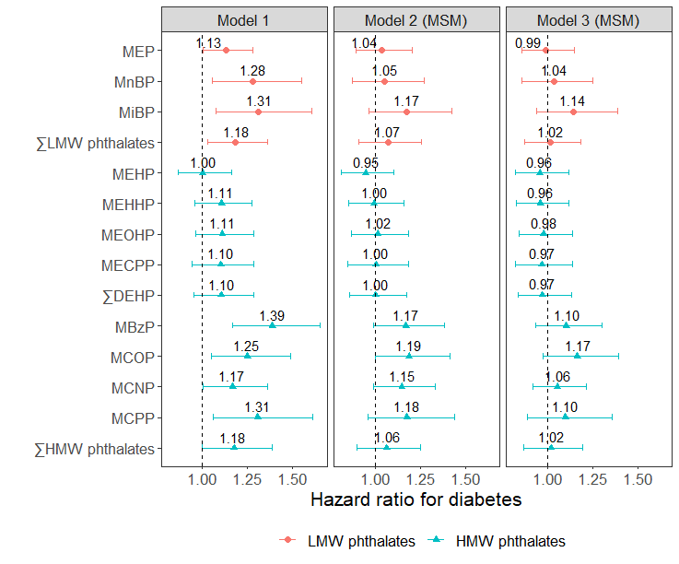

Model 1: Crude model

Model 2 (MSM): Inverse-probability-of-treatment weights accounted for time-varying confounding by menopausal status, physical activity, smoking status, and dietary energy intake. In addition to weighting, the models were adjusted for age in 1999/2000, site and race/ethnicity, and education.

Model 3 (MSM): Inverse-probability-of-treatment weights accounted for time-varying confounding by menopausal status, physical activity, smoking status, dietary energy intake, and BMI. In addition to weighting, the models were adjusted for age in 1999/2000, site and race/ethnicity, and education.

∑LMW phthalates = molar sum of MEP, MnBP, and MiBP; ∑DEHP = molar sum of MEHP, MEHHP, MEOHP, and MECPP; ∑HMW phthalates = molar sum of MEHP, MEHHP, MEOHP, MECPP, MBzP, MCOP, MCNP, and MCPP.

Supplemental Figure S3 Hazard ratios for diabetes per doubling of phthalate metabolite concentrations after incorporating inverse-probability-of-selection weights

**A**

**B**

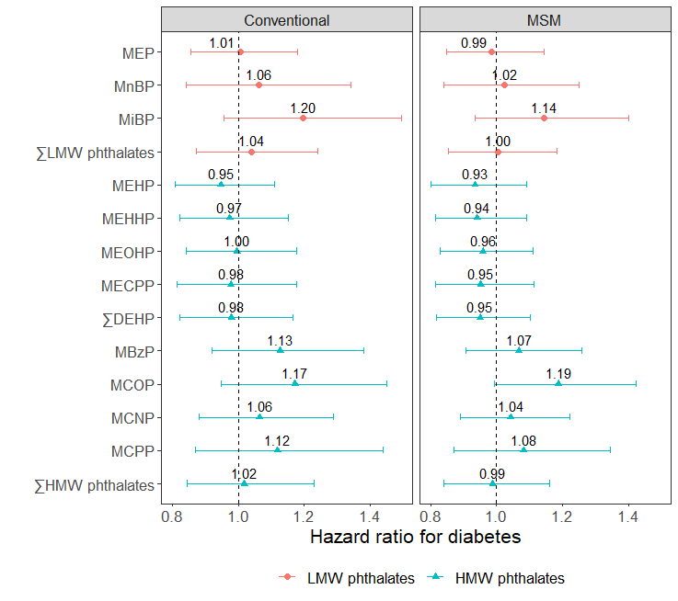

Conventional model: Adjusted for age in 1999/2000, site and race/ethnicity, education, and time-varying menopausal status, physical activity, smoking status, dietary energy intake, and BMI, in addition to weighting for differential selection into SWAN-MPS.

Marginal structural model (MSM): Inverse-probability-of-treatment weights accounted for time-varying confounding by menopausal status, physical activity, smoking status, dietary energy intake, and BMI. Inverse-probability-of-selection weights accounted for differential selection into SWAN-MPS. In addition, the models were adjusted for age in 1999/2000, site and race/ethnicity, and education.

∑LMW phthalates = molar sum of MEP, MnBP, and MiBP; ∑DEHP = molar sum of MEHP, MEHHP, MEOHP, and MECPP; ∑HMW phthalates = molar sum of MEHP, MEHHP, MEOHP, MECPP, MBzP, MCOP, MCNP, and MCPP.

Supplemental Table S6 Hazard ratios for diabetes per doubling of phthalate metabolite concentrations within each racial/ethnic group

|  |  |  |  |
| --- | --- | --- | --- |
|  | Hazard ratio (95% CI) | | |
|  | White | Black | Asian |
| N cases/ N at risk | 25/674 | 27/265 | 9/369 |
|  |  |  |  |
| MEP | 1.10 (0.89, 1.37) | 1.01 (0.81, 1.26) | 0.69 (0.43, 1.13) |
| MnBP | 1.22 (0.87, 1.72) | 0.95 (0.68, 1.32) | 1.24 (0.69, 2.24) |
| MiBP | **1.63 (1.18, 2.25)** | 0.93 (0.63, 1.37) | 0.82 (0.46, 1.49) |
| ∑LMW phthalate metabolites | 1.15 (0.89, 1.47) | 1.04 (0.81, 1.33) | 0.69 (0.38, 1.26) |
|  |  |  |  |
| MEHP | 1.01 (0.80, 1.27) | 0.91 (0.72, 1.15) | 1.09 (0.70, 1.71) |
| MEHHP | 1.09 (0.86, 1.39) | 0.85 (0.64, 1.12) | 1.21 (0.80, 1.83) |
| MEOHP | 1.14 (0.89, 1.45) | 0.88 (0.67, 1.15) | 1.15 (0.74, 1.79) |
| MECPP | 1.18 (0.91, 1.52) | 0.84 (0.62, 1.13) | 0.96 (0.57, 1.60) |
| ∑DEHP metabolites | 1.14 (0.88, 1.46) | 0.85 (0.64, 1.13) | 1.12 (0.70, 1.77) |
|  |  |  |  |
| MBzP | **1.57 (1.18, 2.09)** | 0.92 (0.66, 1.28) | 1.04 (0.65, 1.64) |
| MCOP | **1.43 (1.05, 1.95)** | 1.19 (0.89, 1.59) | 0.59 (0.35, 1.00) |
| MCNP | **1.30 (1.03, 1.65)** | 0.87 (0.64, 1.20) | 0.88 (0.51, 1.53) |
| MCPP | **1.50 (1.06, 2.12)** | 0.98 (0.70, 1.38) | 0.98 (0.53, 1.79) |
| ∑HMW phthalate metabolites | 1.28 (0.97, 1.69) | 0.82 (0.59, 1.15) | 1.14 (0.68, 1.89) |

The hazard ratios were adjusted for age in 1999/2000, site, education, and time-varying menopausal status, physical activity, smoking status, dietary energy intake, and BMI. Racial/ethnic-specific hazard ratios were estimated from Cox proportional hazards models with race/ethnicity by phthalate metabolite interaction terms.

Between Black and White women, the interaction term was statistically significant for MiBP, MBzP, and ∑HMW phthalates, and borderline significant (0.05 < p-value for multiplicative interaction < 0.10) for MECPP, MCNP, and MCPP.

Between Asian and White women, the interaction term was statistically significant for MCOP and borderline significant for MEP and MiBP.

Bold: p-value < 0.05.

∑LMW phthalate metabolites = molar sum of MEP, MnBP, and MiBP; ∑DEHP metabolites = molar sum of MEHP, MEHHP, MEOHP, and MECPP; ∑HMW phthalate metabolites = molar sum of MEHP, MEHHP, MEOHP, MECPP, MBzP, MCOP, MCNP, and MCPP.

Supplemental Table S7 Distributions of covariates, glucose, and insulin in 1999/2000 by race/ethnicity

|  |  |  |  |  |
| --- | --- | --- | --- | --- |
|  | **White**  **(N = 667)** | **Black**  **(N = 262)** | **Asian**  **(N = 364)** |  |
|  | **Median (Q1, Q3)**1 | **Median (Q1, Q3)** | **Median (Q1, Q3)** | **p-value**2 |
| **Age** (years) | 49.2 (47.3, 51.5) | 49.2 (47.2, 51.4) | 49.9 (47.8, 51.6) | 0.03 |
| **BMI** (kg/m2) | 26.0 (22.7, 31.1) | 30.1 (25.8, 35.8) | 22.8 (20.8, 25.3) | <0.0001 |
| **Daily calorie intake** ((kcal/day) | 1653.0  (1326.8, 2071.5) | 1758.4  (1345.8, 2411.2) | 1716.5  (1341.8, 2174.1) | 0.06 |
| **Physical activity index** | 8.1 (7.0, 9.3) | 7.3 (6.3, 8.6) | 7.5 (6.4, 8.8) | <0.0001 |
| **Fasting glucose** (mg/dL) | 87.0 (82.0, 93.0) | 89.0 (84.0, 95.0) | 91.0 (85.0, 97.0) | <0.0001 |
| **Fasting insulin** (µIU/ml) | 8.6 (6.8, 11.6) | 10.7 (7.8, 16.1) | 7.9 (6.6, 10.5) | <0.0001 |
| **HOMA-IR** | 1.8 (1.4, 2.6) | 2.4 (1.7, 3.7) | 1.8 (1.4, 2.5) | <0.0001 |
|  |  |  |  |  |
|  | **N (%)** | **N (%)** | **N (%)** |  |
| **Site** |  |  |  |  |
| Detroit area, MI | 98 (14.7%) | 127 (48.5%) | 0 (0.0%) | <0.0001 |
| Boston, MA | 141 (21.1%) | 70 (26.7%) | 0 (0.0%) | <0.0001 |
| Oakland, CA | 125 (18.7%) | 0 (0.0%) | 168 (46.2%) | <0.0001 |
| Los Angeles, CA | 150 (22.5%) | 0 (0.0%) | 196 (53.8%) | <0.0001 |
| Pittsburgh, PA | 153 (22.9%) | 65 (24.8%) | 0 (0.0%) | <0.0001 |
|  |  |  |  |  |
| **Education** |  |  |  |  |
| High school or less | 75 (11.2%) | 75 (28.6%) | 72 (19.8%) | <0.0001 |
| Some college | 197 (29.5%) | 103 (39.3%) | 109 (29.9%) | <0.0001 |
| College degree | 167 (25.0%) | 47 (17.9%) | 114 (31.3%) | <0.0001 |
| Postgraduate | 228 (34.2%) | 37 (14.1%) | 69 (19.0%) | <0.0001 |
|  |  |  |  |  |
| **Smoking** |  |  |  |  |
| Never | 390 (58.5%) | 143 (54.6%) | 284 (78.0%) | <0.0001 |
| Past | 221 (33.1%) | 64 (24.4%) | 60 (16.5%) | <0.0001 |
| Current | 56 (8.4%) | 55 (21.0%) | 20 (5.5%) | <0.0001 |
|  |  |  |  |  |
| **Menopausal status** |  |  |  |  |
| Pre- or peri- menopausal | 448 (67.2%) | 180 (68.7%) | 285 (78.3%) | 0.0001 |
| Natural/surgical menopause | 94 (14.1%) | 42 (16.0%) | 50 (13.7%) | 0.0001 |
| Unknown due to hormone therapy | 125 (18.7%) | 40 (15.3%) | 29 (8.0%) | 0.0001 |
|  |  |  |  |  |
| **Obesity status**3 |  |  |  |  |
| Normal/underweight | 281 (42.1%) | 50 (19.1%) | 189 (51.9%) | <0.0001 |
| Overweight | 193 (28.9%) | 78 (29.8%) | 124 (34.1%) | <0.0001 |
| Obese | 193 (28.9%) | 134 (51.1%) | 51 (14.0%) | <0.0001 |
|  |  |  |  |  |
| **Incident diabetes** |  |  |  |  |
| No | 642 (96.3%) | 235 (89.7%) | 355 (97.5%) | <0.0001 |
| Yes | 25 (3.7%) | 27 (10.3%) | 9 (2.5%) | <0.0001 |

1 Data in this table were based on the 1293 women who had complete data in 1999/2000. “Q1” means “1st quartile” and “Q3” means “3rd quartile”.

2 P-values were obtained from Kruskal-Wallis tests for continuous variables and Chi-squared tests for categorical variables.

3 Obesity status was defined based on BMI from 1998/1999 for 1248 women, 1997/1998 for 36 women, and 1996/1997 for 9 women using race/ethnicity-specific cut points

Supplemental Figure S4 Percent differences in fasting glucose per doubling of phthalate metabolite concentrations

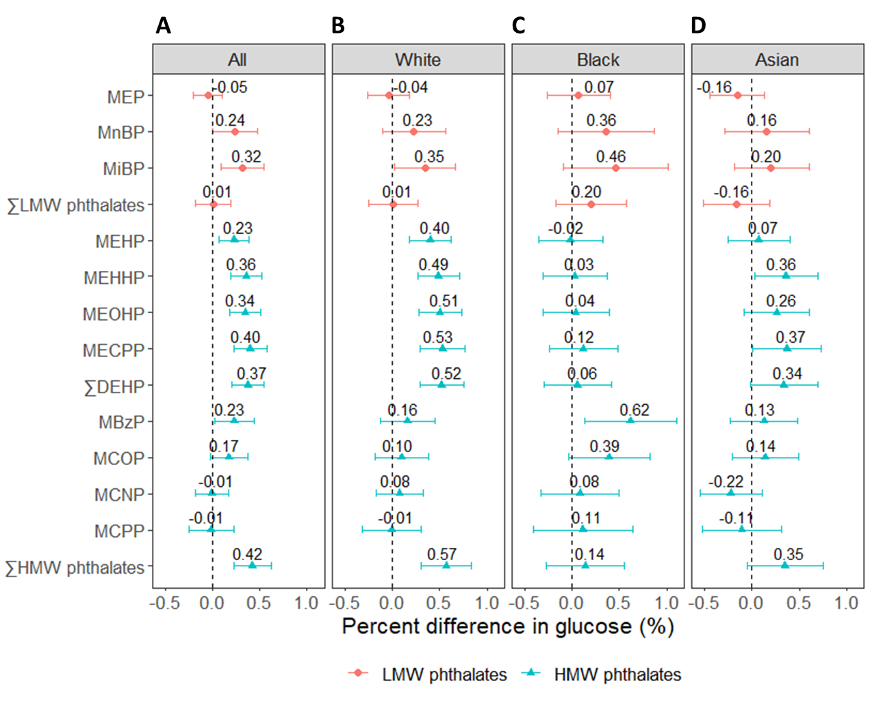

Percent differences were adjusted for age, site, race/ethnicity, education, dietary energy intake, smoking status, physical activity, menopausal status, and BMI in 1999/2000. Between Black and White women, the interaction term was statistically significant for MEHP, MEHHP, MEOHP, and ∑DEHP (p-for-interaction ranged from 0.03 to 0.04) and borderline significant for MECPP, MBzP, and ∑HMW phthalates (p-for-interaction ranged from 0.06 to 0.11). Between Asian and White women, the interaction term for MEHP was borderline significant (p-for-interaction = 0.10). ∑LMW phthalates = molar sum of MEP, MnBP, and MiBP; ∑DEHP = molar sum of MEHP, MEHHP, MEOHP, and MECPP; ∑HMW phthalates = molar sum of MEHP, MEHHP, MEOHP, MECPP, MBzP, MCOP, MCNP, and MCPP.

Supplemental Figure S5 Percent differences in HOMA-IR per doubling of phthalate metabolite concentrations

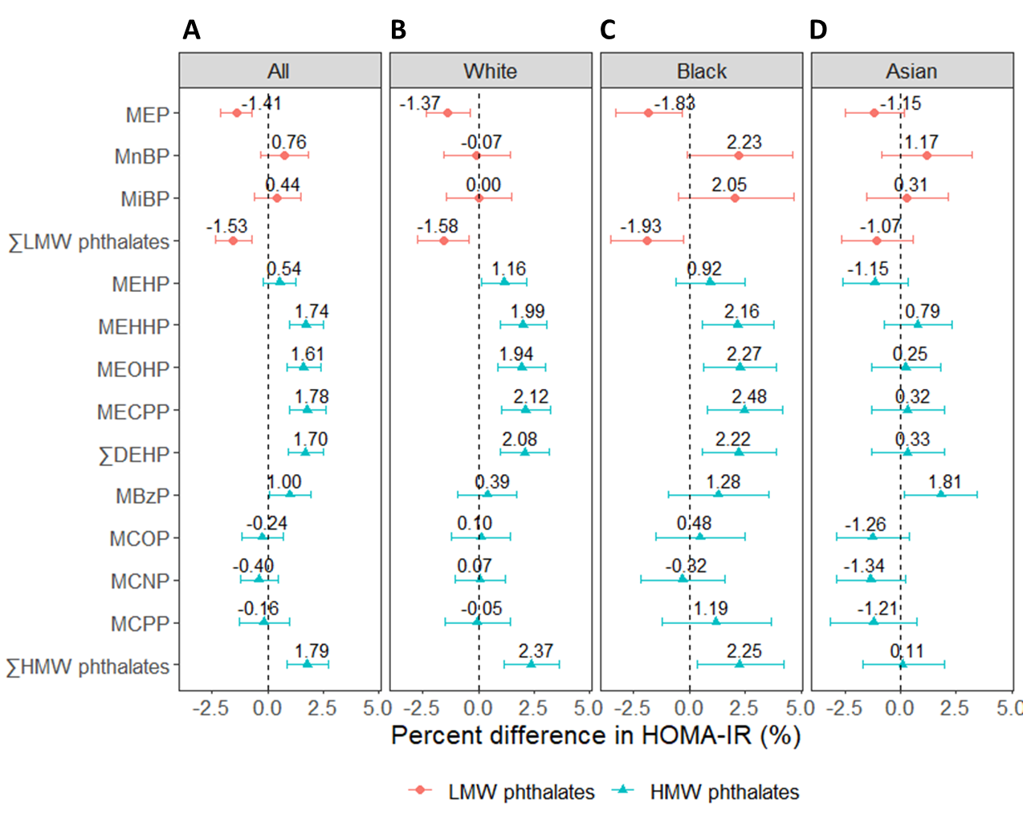

Percent differences were adjusted for age, site, race/ethnicity, education, dietary energy intake, smoking status, physical activity, menopausal status, and BMI in 1999/2000. Between Black and White women, the interaction term was borderline significant for MnBP (p-for-interaction = 0.11). Between Asian and White women, the interaction term was statistically significant for MEHP and ∑HMW phthalates (p-for-interaction = 0.01 and 0.047, respectively) and borderline significant for MEOHP, MECPP, and ∑DEHP (p-for-interaction all equaled 0.08). ∑LMW phthalates = molar sum of MEP, MnBP, and MiBP; ∑DEHP = molar sum of MEHP, MEHHP, MEOHP, and MECPP; ∑HMW phthalates = molar sum of MEHP, MEHHP, MEOHP, MECPP, MBzP, MCOP, MCNP, and MCPP.